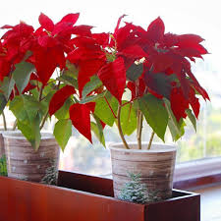

Scientific name: Euphorbia pulcherrima

Classification: [Tropical plant](https://getbusygardening.com/tropical-houseplant-care/)

Common names: Poinsettia, Christmas Star

**Height:** Varies from 6 in (15 cm) miniatures to 36 in (90 cm) tall, full plants

**Light:** Poinsettia grows best in bright, indirect light. Some direct morning sun is fine, but hot direct midday sun can cause bract color to fade.

**Water:** Water thoroughly, then allow top of soil to dry out between waterings. Remove the decorative foil to allow good drainage. This plant is prone to root rot if soil is too soggy.

**Humidity:** Average room humidity (around 40% relative humidity). Indoor air can become extremely dry in winter; check out these easy ways to [increase humidity](https://www.guide-to-houseplants.com/humidity.html) for your tropical plants.

**Temperature:** Average room temperatures 60-75°F/15-24°C. It doesn't like cold drafts from doors and windows. Exposing it to temperatures below 50°F/10°C can cause its leaves to drop.

**Soil:** Peat moss based potting mix

**Fertilizer:** Not usually necessary, but if the poinsettia is kept for another season it will benefit from a high-phosphorus fertilizer diluted by half every 2 weeks.

**Propagation:** Take 3 in (7.5 cm) stem tip cuttings when new growth starts in spring or early summer. Cuttings will ooze a milky sap that can be stopped by placing the cut end in water before potting it.